2026 – 2027
IoT Essentials
IoT Group project
Smart Desk
Ergonomics and climate control for the home workplace
Team
Eggermont Dimitri – team leader / software
Lauwers Björn – documentation / hardware
Thomas More

Contents
1. What?
2. Added value
3. IoT Information-Value Loop
4. Requirements
5. System design
6. Hardware
7. Software
8. Team composition
9. Planning
10. Demo video
11. Self-evaluation

1. What?
We are building a Smart Desk System around a Raspberry Pi 5 and a Raspberry Pi Pico 2 W. It automates the ergonomics and the climate of a home workplace: it notices when someone arrives, keeps track of how long they sit, corrects their posture, and controls light, sunshade and cooling. Everything is shown on a local OLED display and on an online dashboard.
The demo setup is a scale model of a desk and room (about 30–50 cm). The webcam that checks posture watches a real team member sitting next to the model.
Presence & activity tracking
- An ultrasonic sensor (HC-SR04) at the entrance of the model room detects someone coming in and wakes the system.
- A push button under the seat is read by the Pico 2 W, which publishes the seat state over Wi-Fi with MQTT to the broker on the Pi.
- The Pi counts how long the user has been sitting. After a set time (for the demo: 1 minute) it sends a movement reminder (e.g. squats, a short walk) to the phone and PC.
Environment control
- A digital light sensor (BH1750, I²C) measures the light on the desk. Below the threshold, the LED desk lamp is dimmed up with PWM. The threshold is set with a potentiometer (MCP3008, SPI).
- An analog light sensor at the window (LDR via MCP3008) controls a stepper-motor sunshade: it closes on strong sunlight and opens again when it gets darker.
- A temperature sensor (BMP280, I²C) switches a small DC fan through a relay. A push button gives manual override (fan on/off).
- The current environment values and system status are shown on the OLED display (SPI).
AI posture detection & feedback
- A USB webcam with an AI pose-estimation model (YOLO pose) measures the angle of the neck and back in real time.
- An RGB LED gives instant feedback: green = good posture, red = bad posture, blue = nobody at the desk.
- If bad posture lasts too long, a warning is pushed to the phone/PC with ntfy.
Data logging & dashboards
- Sensor values, seated time and posture quality are stored in a MariaDB database on the Pi.
- A selection of values is sent every 15 s to an online ThingSpeak dashboard (via MQTT), which can also be viewed on a phone.

2. Added value
- Ergonomics & health: combines active posture correction with automatic break and movement reminders, to reduce physical strain, the risks of sitting for long periods, and fatigue.
- Comfort & energy efficiency: automatically balances daylight and artificial light and regulates the temperature, and only when someone is actually present.
- Data-driven insights: the online dashboard and the database give historical trends on work habits, posture improvement and the indoor climate.
- Privacy by design: camera images are processed locally on the Pi and never stored or sent. Only the result (good/bad posture) leaves the device (GDPR).

3. IoT Information-Value Loop
The Smart Desk goes through all five stages of the information-value loop from the course. The actions influence the user and the environment, which in turn produces new data. That closes the loop.
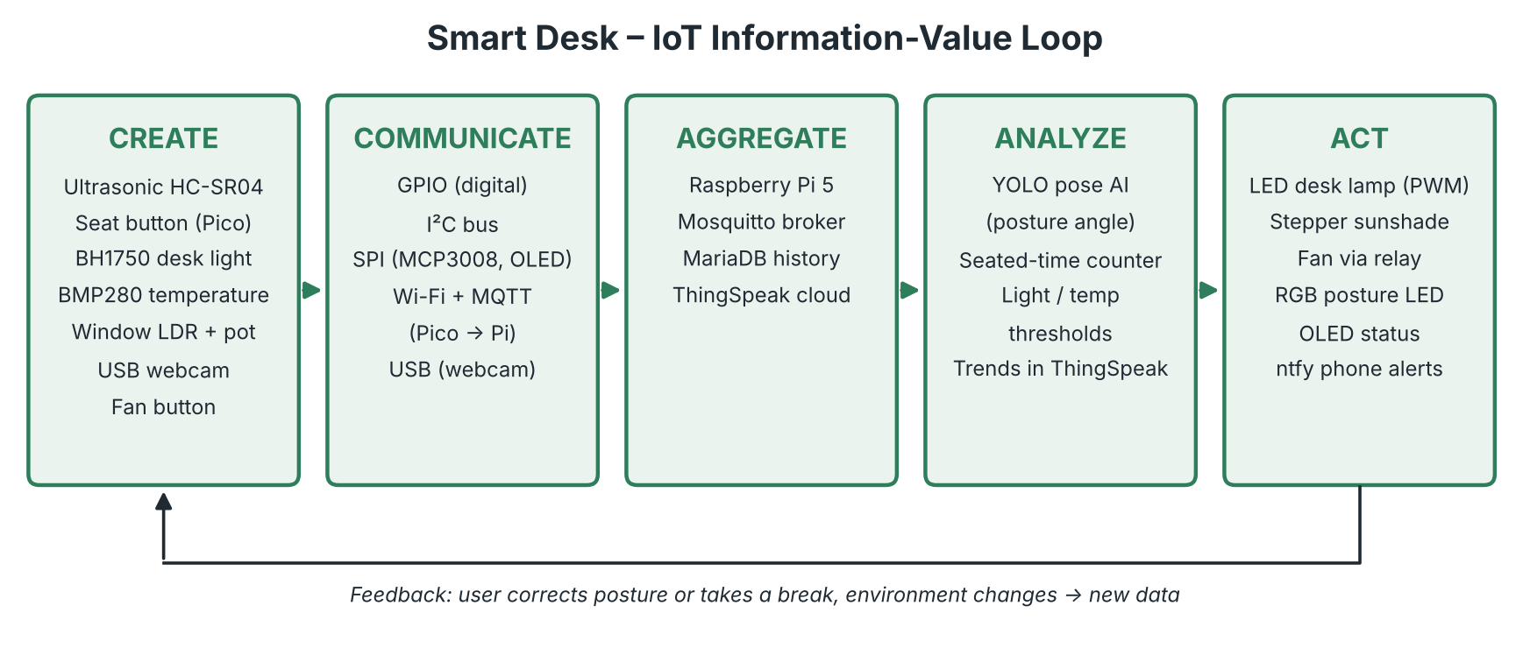
Figure 1 – Information-value loop of the Smart Desk
Stage | Smart Desk implementation
Create | HC-SR04 (presence), seat push button on the Pico, BH1750 (desk lux), BMP280 (temperature), window LDR and threshold potentiometer (via MCP3008), USB webcam (posture), manual fan button.
Communicate | Embedded: GPIO, I²C (BH1750, BMP280), SPI (MCP3008, OLED), USB (webcam). Non-embedded: Wi-Fi + MQTT from Pico to Pi, MQTT to ThingSpeak, HTTPS to ntfy.
Aggregate | Raspberry Pi 5 as embedded platform with a local Mosquitto broker and a MariaDB database. ThingSpeak as cloud platform.
Analyze | AI pose estimation (YOLO pose) → posture angle → good/bad. Rules for seated time, light and temperature thresholds (prescriptive). Trends in ThingSpeak (descriptive).
Act | LED desk lamp (PWM), stepper sunshade, fan via relay, RGB posture LED, OLED status screen, push notifications via ntfy. The user acts too: sits up straight, takes a break.

4. Requirements
Mapping of the project requirements (Team Project v2) to the Smart Desk:
Requirement | How the Smart Desk meets it | Components
Digital input (incl. ultrasonic) | Presence detection at the entrance; manual fan button; seat button (on the Pico) | HC-SR04, push buttons
I²C sensor | Desk light level and room temperature on one I²C bus | BH1750 (0x23), BMP280 (0x76/0x77)
SPI (analog input ADC) | Threshold potentiometer and window LDR read through the ADC | MCP3008 (CH0 pot, CH1 LDR)
Raspberry Pi | Central controller, broker, database, AI | Raspberry Pi 5
Raspberry Pi Pico | Wireless seat sensor in the chair | Pico 2 W
MQTT | Pico → Pi (local Mosquitto); internal topics between programs; Pi → ThingSpeak | Mosquitto, paho-mqtt, adafruit_minimqtt
Online dashboard | 8 live fields, can be viewed on a phone | ThingSpeak
Local dashboard (OLED) | Lux, temperature, seated time, posture, fan/shade status | SSD1306 OLED 128×64 (SPI)
AI | Posture detection with pose estimation | USB webcam, YOLO pose (ultralytics)
Digital output incl. motor | Fan relay, RGB LED, stepper sunshade | Relay board, RGB LED, 28BYJ-48 + ULN2003
PWM | Dimmable LED desk lamp | 2 LEDs on hardware PWM (GPIO12)

5. System design

5.1 Architecture
The Raspberry Pi 5 runs three Python programs that talk to each other through the local Mosquitto broker. This keeps the AI (heavy, slow) separate from the sensor loop (fast), and MQTT is used inside the system as well.
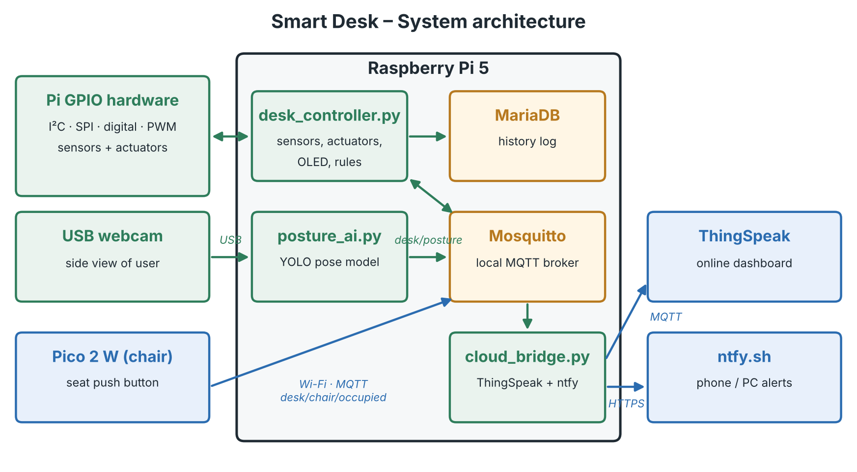
Figure 2 – System architecture

5.2 MQTT topics
Topic | Publisher | Payload | Subscriber(s)
desk/chair/occupied | Pico 2 W | 1 / 0 (only on change) | desk_controller
desk/presence | desk_controller | 1 / 0 | cloud_bridge
desk/posture | posture_ai | JSON: state (good/bad/none), angle | desk_controller, cloud_bridge
desk/env | desk_controller | JSON: lux, temp, window %, threshold | cloud_bridge
desk/actuators | desk_controller | JSON: lamp %, fan, shade % | cloud_bridge
desk/alert | desk_controller | text (break / posture warning) | cloud_bridge → ntfy

5.3 Behaviour (rules)
Trigger (input) | Action (output)
Distance drops clearly below the startup baseline (someone enters) | System wakes up: OLED on, logging starts, presence = 1
No presence and no seat for X minutes | Lamp, fan and RGB off; OLED shows standby
Seat occupied longer than limit (demo: 1 min) | ntfy reminder "time to move: 10 squats or a short walk"; OLED shows timer
Desk lux < threshold (set with potentiometer) | LED lamp dims up with PWM, proportional to the shortfall
Window light > limit | Stepper closes sunshade; opens again below limit (with hysteresis)
Temperature > limit (e.g. 25 °C) | Relay switches fan on; off below limit − 1 °C
Fan button pressed | Manual override: fan toggles regardless of temperature
AI posture = bad for > 10 s | RGB LED red; ntfy warning (max. once per few minutes)
AI posture = good | RGB LED green
AI: no person in view | RGB LED blue

6. Hardware

6.1 Components
Component | Function | Interface | Source
Raspberry Pi 5 + 27 W power supply | Central controller | – | Own
Raspberry Pi Pico 2 W(H) | Seat sensor node | Wi-Fi / MQTT | School
HC-SR04 ultrasonic sensor | Presence at entrance | Digital (GPIO) | Kit
BH1750 light sensor | Desk light level | I²C | Kit
BMP280 sensor | Room temperature | I²C | Kit
MCP3008 ADC | Read analog sensors | SPI | Kit
10 kΩ potentiometer | Light threshold | Analog via MCP3008 | Kit
LDR + 10 kΩ resistor | Window light | Analog via MCP3008 | Kit
SSD1306 OLED 128×64 | Local dashboard | SPI | Kit
28BYJ-48 stepper + ULN2003 | Sunshade | Digital (4 GPIO) | Kit
Relay board | Switch fan | Digital (GPIO) | Kit
Small DC fan | Cooling | Via relay | Own
2 LEDs + 2 × 220 Ω | Desk lamp | PWM | Kit
RGB LED (common cathode) + 3 × 220 Ω | Posture feedback | Digital (3 GPIO) | Kit
2 push buttons | Fan override (Pi), seat (Pico) | Digital input | Kit
USB webcam | AI posture detection | USB | Own
Breadboard, jumper wires, cardboard/wood | Scale model (30–50 cm) | – | Kit / own

Everything is covered by the course kit or our own material: nothing needs to be bought.

6.2 Pin plan Raspberry Pi 5
Function | GPIO (BCM) | Remark
I²C SDA / SCL (BH1750 + BMP280) | 2 / 3 | Shared bus, different addresses
SPI SCLK / MOSI / MISO | 11 / 10 / 9 | Shared by MCP3008 and OLED
MCP3008 CS | 24 | Software chip select
OLED CS / DC / RST | 5 / 6 / 4 | Check if the module has a CS pin
Desk lamp LEDs (PWM) | 12 | Hardware PWM channel
RGB LED R / G / B | 13 / 19 / 26 | Plain digital outputs
Stepper IN1 – IN4 | 17 / 27 / 22 / 23 | Via ULN2003 driver, 5 V supply
Ultrasonic TRIG / ECHO | 20 / 21 | Voltage divider on ECHO (5 V → 3.3 V)
Fan relay IN | 16 | Active low
Fan button | 25 | Internal pull-up
Spare | 14, 15, 18 | –

GPIO 7 and 8 are not used, because they are the hardware SPI chip-select lines.

6.3 Pin plan Pico 2 W
Function | Pin | Remark
Seat push button | GP15 → GND | Internal pull-up, pressed = seated
Status LED | Onboard LED | On = Wi-Fi and MQTT connected
Power | USB | From the Pi or a laptop (scale model)

6.4 Wiring notes
- HC-SR04: the 5 V version returns a 5 V ECHO signal. A voltage divider (1 kΩ / 2 kΩ, or 2 × 1 kΩ) protects the 3.3 V GPIO.
- LEDs: maximum about 15 mA per GPIO pin. With 220 Ω each LED draws about 7 mA, so 2 LEDs per pin is safe.
- Fan: only the relay input is connected to the GPIO. The fan gets its own supply through the relay contact (COM → NO).
- Temperature: the BMP280 is used instead of the LM35, because the LM35 is specified for 4–30 V and is unreliable on 3.3 V.
- Ultrasonic in a scale model: at startup a baseline distance is measured (wall of the model). A clear drop below the baseline means "someone enters".
- Power: the Pi 5 runs on its official 27 W supply, because the stepper motor and the webcam draw too much current for a laptop USB port.

6.5 Schematic and setup
TO ADD: Schematic (e.g. Fritzing) of the Pi 5 and Pico wiring.
TO ADD: Photo(s) of the finished scale model, with a short description of where each sensor and actuator sits.

7. Software

7.1 Program structure
Program | Runs on | Responsibility | Main libraries
desk_controller.py | Pi 5 | Reads all sensors, runs the rules, drives actuators and OLED, logs to MariaDB, publishes desk/* | gpiozero / lgpio, adafruit-circuitpython-bh1750, -bmp280, -mcp3xxx, -ssd1306, paho-mqtt, mariadb
posture_ai.py | Pi 5 | Grabs ~1 frame per second, YOLO pose keypoints (ear, shoulder, hip) → angle → good/bad, publishes desk/posture | ultralytics (yolo11n-pose, NCNN export), opencv-python, paho-mqtt
cloud_bridge.py | Pi 5 | Subscribes to desk/#, sends 8 fields to ThingSpeak every 15 s, forwards desk/alert to ntfy | paho-mqtt, requests
code.py | Pico 2 W | Reads the seat button (debounced), publishes desk/chair/occupied on change | CircuitPython, adafruit_minimqtt, wifi, socketpool

Mosquitto configuration: by default Mosquitto 2.x only accepts connections from the Pi itself. For the Pico, listener 1883 and allow_anonymous true (or a password file) are added to /etc/mosquitto/conf.d/.

7.2 Online dashboard (ThingSpeak)
Field | Value | Field | Value
field1 | Desk light (lux) | field5 | Posture (1 = good, 0 = bad)
field2 | Temperature (°C) | field6 | Presence (1/0)
field3 | Window light (%) | field7 | Fan state (1/0)
field4 | Seated time (min) | field8 | Sunshade position (%)

Data is sent through mqtt3.thingspeak.com on topic channels/<channel ID>/publish, at most once every 15 seconds (free-tier limit).

7.3 Notifications (ntfy)
Movement reminders and posture warnings are sent with a simple HTTP POST to a private ntfy topic. The team members subscribe to it in the ntfy app on their phone and in the browser on their PC. A cooldown prevents too many messages.

7.4 Privacy
The webcam stream is analysed only in memory on the Pi. No images or videos are stored or sent. Only the posture result (good/bad + angle) is logged.

7.5 Code
TO ADD: Full code with inline comments (desk_controller.py, posture_ai.py, cloud_bridge.py, Pico code.py).

8. Team composition
Every team member works on all parts of the project. The specific responsibilities are:
Team member | Role | Responsibilities
Eggermont Dimitri | Team leader / Software | Contact with the coaches, uploads the final project on Canvas; program structure, MQTT, AI, dashboard and inline comments
Lauwers Björn | Documentation / Hardware | Final report and YouTube video; physical setup, wiring and the scale model

9. Planning
Week | Goal
1 | Concept, requirements, pin plan; check all components
2 | Sensors on the Pi: HC-SR04, BH1750, BMP280, MCP3008 (pot + LDR)
3 | Actuators: PWM lamp, RGB LED, relay + fan, stepper sunshade; OLED
4 | Pico seat sensor over MQTT; Mosquitto config; AI posture detection
5 | Integration, MariaDB, ThingSpeak, ntfy; build the scale model
6 | Testing, video recording, report, self-evaluation, presentation

10. Demo video
The video (max. 5 minutes) proves every evaluation criterion one by one:
- A hand or figure enters the model room → system wakes up (ultrasonic).
- Covering the BH1750 → LED lamp dims up; turning the potentiometer changes the threshold (I²C, SPI, PWM).
- Phone flashlight on the window LDR → sunshade closes (SPI, stepper).
- Warming the BMP280 with a finger → fan switches on; fan button overrides it (relay).
- Pressing the seat button → Pico publishes over MQTT, the OLED shows the seat timer, and after 1 minute a reminder appears on the phone.
- A team member slouches next to the model → RGB LED red and ntfy warning; sits up straight → green (AI).
- ThingSpeak dashboard on screen with the live values (online dashboard).
TO ADD: YouTube link to the demo video.

11. Self-evaluation
Scores are filled in after the setup is finished. The motivation lists what proves each item.
Item | Max | My score | Motivation
Original concept / creativity | 2 |  | Smart desk combining ergonomics (AI posture, movement reminders) with climate and light control – a different application than the example
Digital: in/out, PWM (incl. motor and ultrasonic) | 2 |  | HC-SR04, buttons, relay, RGB LED, PWM desk lamp, stepper sunshade
I2C | 2 |  | BH1750 and BMP280 on one I²C bus
SPI: Analog in, OLED | 2 |  | MCP3008 with potentiometer and LDR; SSD1306 OLED status screen
MQTT via Pico | 2 |  | Pico 2 W publishes the seat state over Wi-Fi to the Mosquitto broker on the Pi
Dashboard local/online | 2 |  | OLED (local) and ThingSpeak (online), plus ntfy notifications
Extra: AI, … | 2 |  | Real-time posture detection with YOLO pose estimation; MariaDB logging
Presentation / demo / questions | 4
Report / video | 2
Total | 20

